|  |
| --- |
| , RD Dep.  MTN.*NIX.07 Oracle DB. Introduction to DWH |
| MTN.*NIX.07 Labs - Star Schema Basics |

|  |  |  |  |  |  |
| --- | --- | --- | --- | --- | --- |
| REVISION HISTORY | | | | | |
| Ver. | Description of Change | Author | Date | Approved | |
| Name | Effective Date |
| 1.0 | Initial status of document | [**Kiryl Bucha**](mailto:Kiryl_bucha@epam.com) | 16-JAN-2012 |  |  |
|  |  |  |  |  |  |

# OLTP – Load External References – Normalization of Data

## Task 01 – Install and expand load of external references T_Languages



* Create sql: Showing result of data on next objects:
  + t_localizations
  + 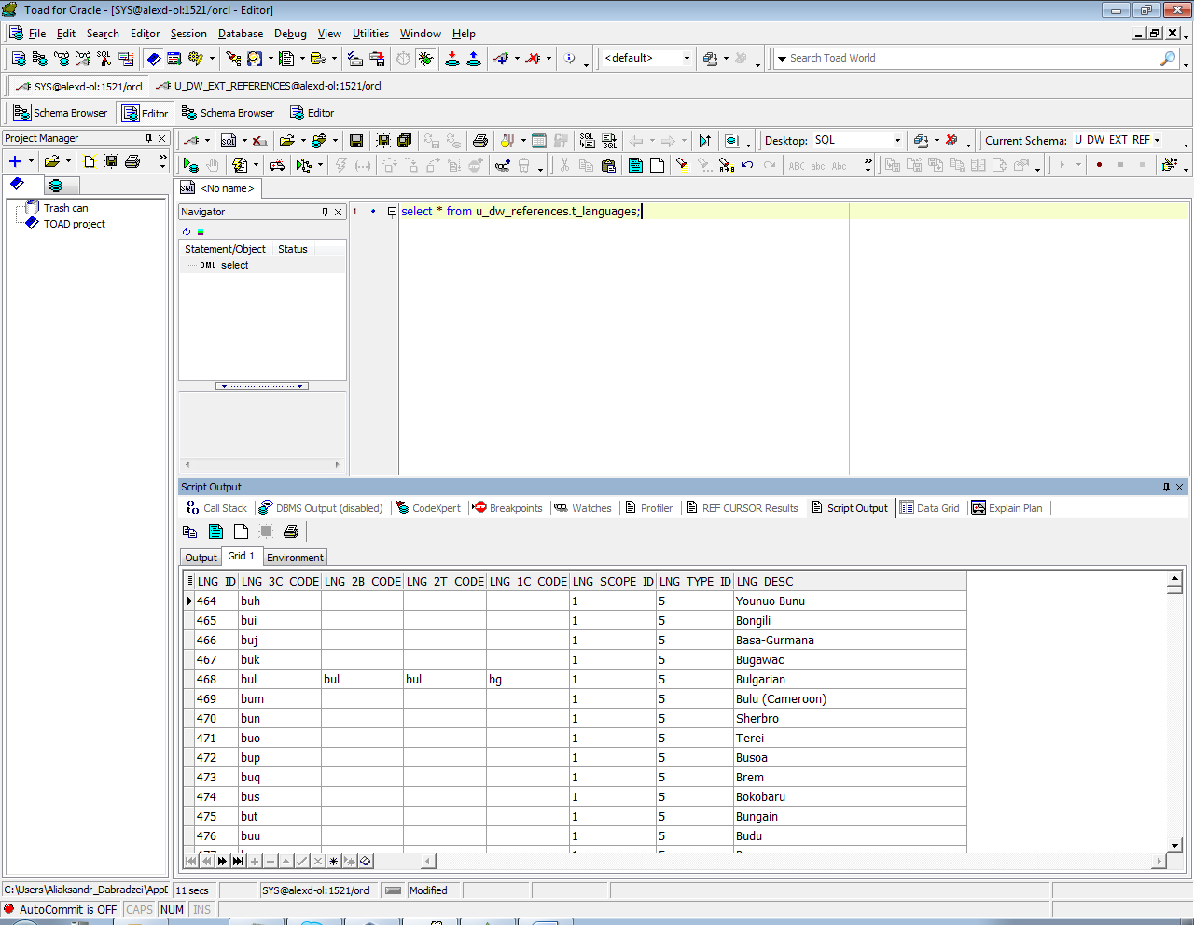
  + cu_languages

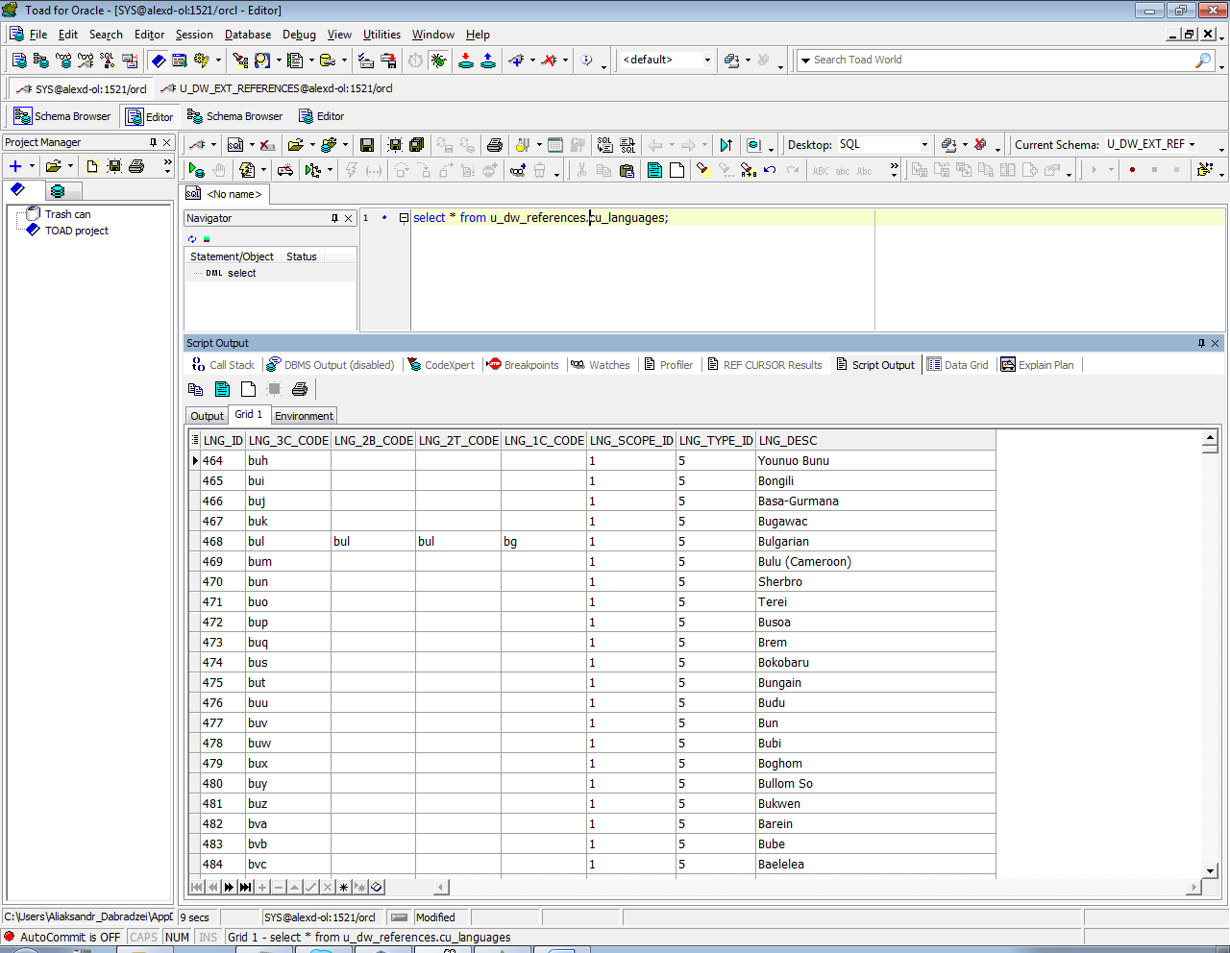

* + w_lng_links

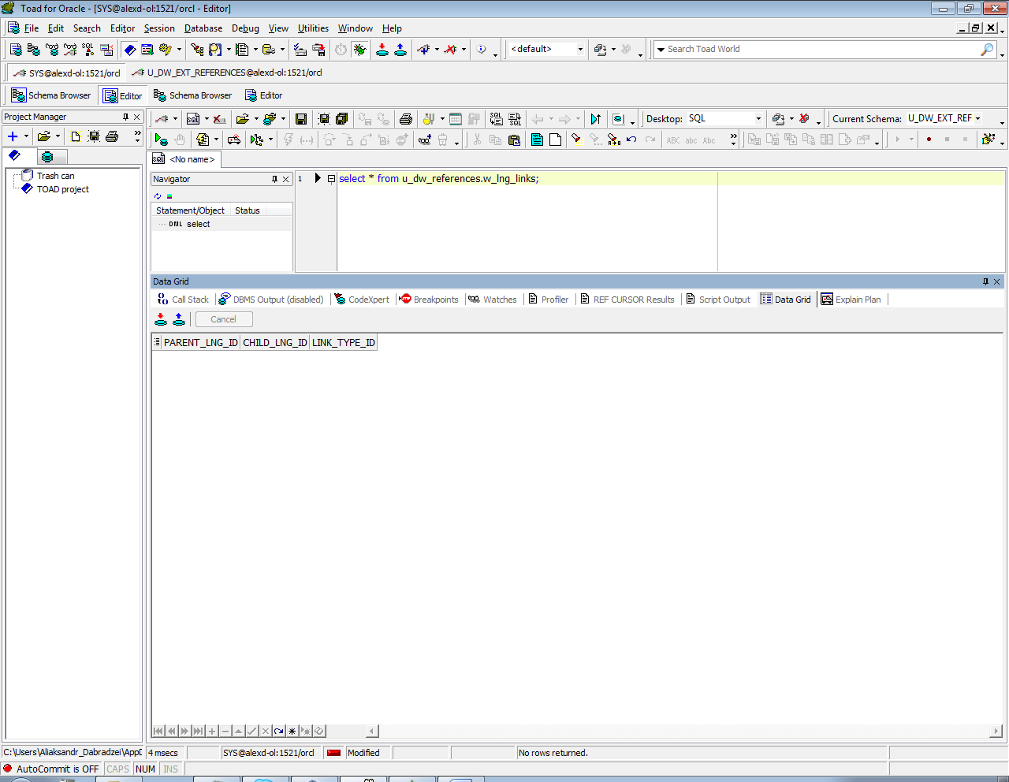

* + cu_lng_scopes

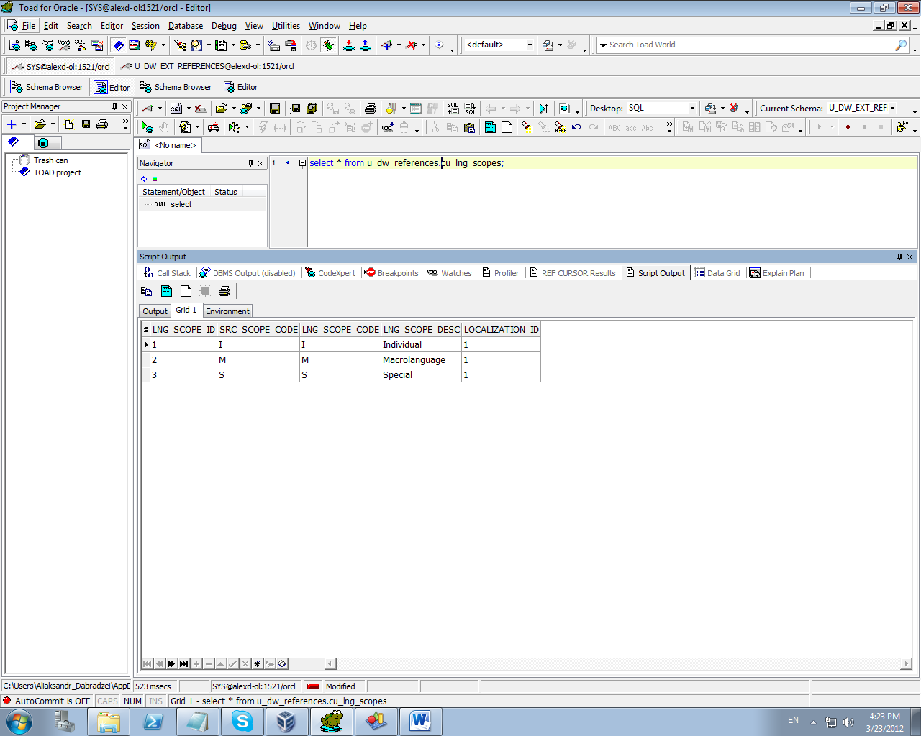

* + cu_lng_types

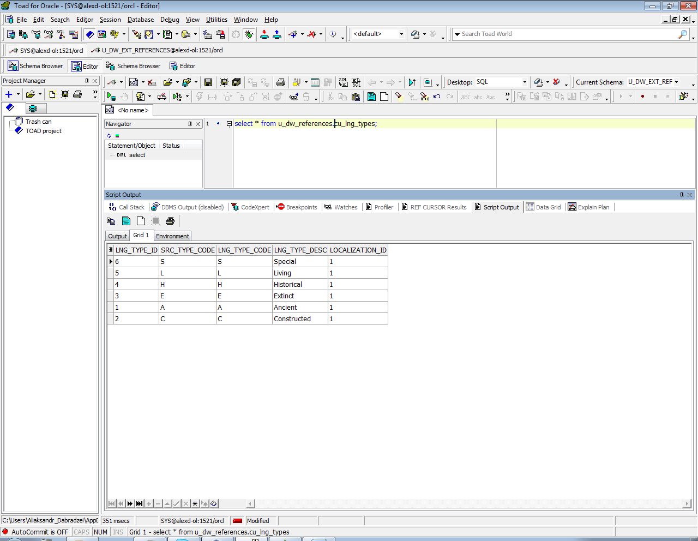

## Task 02 – Create load process for External references T_Countries

Description of External Resources:

|  |  |
| --- | --- |
| File Name | Path |
| iso_3166.tab | …\Topic 06 - Star Schema Basics\External_References |
| iso_3166_geo_un.tab | …\Topic 06 - Star Schema Basics\External_References |
| iso_3166_geo_un_contries.tab | …\Topic 06 - Star Schema Basics\External_References |
| iso_3166_groups_un.tab | …\Topic 06 - Star Schema Basics\External_References |
| iso_3166_groups_un_contries.tab | …\Topic 06 - Star Schema Basics\External_References |

### iso_3166.tab – Storage of Countries

|  |  |  |
| --- | --- | --- |
| Name | Data Type | Comment |
| con_code | NUMBER( 3 CHAR ) | iso 3166 code |
| con_name | VARCHAR2( 60 CHAR ) | iso 3166 name of the country |
| con_3c_code | VARCHAR2( 3 CHAR ) | iso alpha-3 code |

### iso_3166_geo_un.tab – Storage of Countries Geo Groups

|  |  |  |
| --- | --- | --- |
| Name | Data Type | Comment |
| geo_ code | NUMBER( 3 CHAR ) | iso 3166 geo code |
| p_geo_ code | NUMBER( 3 CHAR ) | iso 3166 parent geo identifier |
| geo_name | VARCHAR2( 60 CHAR ) | iso 3166 geo name |
| geo_type | VARCHAR2( 15 CHAR ) | iso 3166 geo type |

### iso_3166_geo_un_contries.tab – Store of Links Between Geo and Individual Countries

|  |  |  |
| --- | --- | --- |
| Name | Data Type | Comment |
| con_ code | NUMBER( 3 CHAR ) | iso_3166 country code |
| con_name | VARCHAR2( 60 CHAR ) | iso_3166 name of the country |
| geo_ code | NUMBER( 3 CHAR ) | iso_3166 geo code |
| geo_name | VARCHAR2( 60 CHAR ) | iso_3166 geo name |

### iso_3166_groups_un.tab – Storage of Countries Geo Groups

|  |  |  |
| --- | --- | --- |
| Name | Data Type | Comment |
| grp_ code | NUMBER( 3 CHAR ) | iso 3166 group code |
| p_grp_ code | NUMBER( 3 CHAR ) | iso 3166 parent group code |
| grp_name | VARCHAR2( 60 CHAR ) | iso 3166 group name |
| grp_type | VARCHAR2( 15 CHAR ) | iso 3166 group type |

### iso_3166_geo_un_contries.tab – Store of Links Between Groups and Individual Countries

|  |  |  |
| --- | --- | --- |
| Name | Data Type | Comment |
| con_ code | NUMBER( 3 CHAR ) | iso_3166 country code |
| con_name | VARCHAR2( 60 CHAR ) | iso_3166 name of the country |
| grp_ code | NUMBER( 3 CHAR ) | iso_3166 geo-group code |
| grp_name | VARCHAR2( 60 CHAR ) | iso_3166 geo-group name |

# OLAP – Business analyses task

## Task 03 – Solution concept – Business background



# OLAP – Develop Star-Scheme and SnowFlake Scheme.

## Task 04 – Develop Star-Scheme physical diagram

